This template lays out all the different sections that you need to complete for Project One. Each section has guiding questions to prompt your thinking. These questions are meant to guide your initial responses to each area. You are encouraged to go beyond these questions using what you have learned in your readings. You will need to continually reference the interview transcript as you work to make sure that you are addressing your client’s needs. There is no required length for the final document. Instead, the goal is to complete each section based on your client’s needs.

**Tip:** You should respond in a bulleted list for each section. This will make your thoughts easier to reference when you move into the design phase for Project Two. One starter bullet has been provided for you in each section, but you will need to add more.

## System Components and Design

### Purpose

*What is the purpose of this project? Who is the client and what do they want their system to be able to do?*

* Driving school whose aim is to make driving instruction available from anywhere and any device, online and offline through the use of a software application
* On demand driving training in person with a professional instructor and company provided car
* Provide convenient, in-depth lessons

### System Background

*What does DriverPass want the system to do? What is the problem they want to fix? What are the different components needed for this system?*

* Based on the DMV statistics, a large number of drivers are failing their tests. DriverPass sees the need for much better and focused training and wants to deliver this training online and in person
* DriverPass wants to offer an application to help student drivers pass their tests by providing online training and an online portal to schedule in person training with professional, licensed drivers
* The students will have access to the most current DMV rules and practice tests, will be able to schedule and modify appointments for drive training online through the app, and have access to classroom training online through the application. There will be cars and drivers available through various packages students can purchase to help them become licensed drivers
* The system will need an ordering component, user accounts, databases and will exist in the cloud for delivery over the internet, and will have an admin section for updates by the company IT admin

### Objectives and Goals

*What should this system be able to do when it is completed? What measurable tasks need to be included in the system design to achieve this?*

* Access to lessons online and offline
* Book and manage 2 hour appointments for driving practice with a professional driving instructor.
* It shold act like MyChart and Uber at the same time. Students can book appointments and have driving instructors come to their location for in person training.
* Give students the ability to view notes from lessons
* Give information about the instructors
* Show any testing history and progress
* Allow students to contact the school through the app
* Allow a place to provide information on any special needs a student may have

## Requirements

### Nonfunctional Requirements

#### Performance Requirements

* System should allow a large number of users at once and run on a smart phone, tablet and PC. It will require a connection to the internet. A web application hosted in the in the cloud is required to keep security and necessary upgrading taken care of by the cloud provider.
* The code base will be easier to maintain as a web application and updates will occur as needed for critical bugs that affect the functionality of the system and monthly for non-critical updates.
* Speed. No request should take more than 4 seconds to process (Godskind 2009). Users will likely move on if it takes longer than this for a page to load.

#### Platform Constraints

* Amazon, Google and Microsoft have cloud services that provide hosting for apps like this. Hosting the app here will make upgrading the hardware as needed much easier and help manage user load. It also gives options for databases.
* A database will need to be used so that appointments can be made and stored as well as viewed and changed. A database will also hold other necessary information, such as

#### Accuracy and Precision

* User names will be required to login to the system and each user name must be unique. User names should not be case sensitive to ensure only one instance of any user name can be created and used
* Admin should receive a message for errors on the site, such as a request that takes longer than 4 seconds or a failure to connect to a database to update information

#### Adaptability

* The system should be able to change packages and add features
* The IT admin will need access to the back end to add features and modules to the application as needed as well as password resets or other account maintenance
* Any information from outside, such as DMV updates should be easily updated within the system

#### Security

* AES encryption is used by the Government. This is necessary to protect the customers’ personal data, so there must be encryption on any transfer of information over the internet.
* Users should be required to login with password and username and be allowed to reset forgotten passwords via automated email process. No more than 5 failed attempts should be allowed for logging in or the account is locked. Locked accounts will require a password reset.

### Functional Requirements

* Must be able to register account
* Customers are required to login with user name and password
* Account locks after 5 failed login attempts
* Must allow appointments to be created, canceled and updated.
* Allow students to specify pick up and drop off locations for in car training sessions
* Allow a student to update their personal information, choose drivers and packages
* Track which driver is scheduled with which student
* Provide a way to view and participate in online classes
* Must allow student to take practice tests online

### User Interface

* The user interface should have the following components:
  + The logo at the top
  + Online test progress. This would show name, time, score and status of tests taken and should show “In progress”, “Failed”, or “Passed”
  + Driver Notes where the driver can place comments in a table for lesson time, start hour, end hour and any additional comments
  + Driver information
  + Any special provisions needed for the driver
  + Driver Photo
  + Student Photo

**Business**

* Customers should be able to choose three different packages
  + Six hours with a trainer in a car
  + Eight hours with a trainer in a car and in person lessons for DMV rules and policies
  + Twelve hours with a trainer in a car and in person lessons for DMV rules and policies as well as access to online class
* Packages should be disabled if there are is a business need, such as full capacity for that package
* App should follow all DMV rules and reflect any changes as they occur in the DMV rules and policies and practice tests should reflect current laws and regulations through API if possible
* Allow admin access to data when offline as well as online

**Users and Access**

* Customers
  + Should be allowed to update personal information, schedule and modify appointments, and reset passwords
* IT Admin
  + Reset passwords and system maintenance, such as updating any DMV policies, rules or practice tests
* Company Owner
  + All access

**Tracking and Reporting**

* Admin should see activity reports showing who made, canceled or updated appointments.
* Track the number of appointments against how many trainers or cars are available

### Assumptions

* **Technology**. It is assumed that all users will have a smart phone, tablet, or PC for accessing the web and the site to manage their experience manually. There is a person in the office in the event customers do not have this technology so they can set up their appointments over the phone.
* **Knowledge**. Assume people do not understand technology enough to use the interface with little to no instruction so that the interface is as simple to use as possible
* **Accountability**. Students will use the app and the features they paid for. They will take responsibility for their lessons, follow through, and learn by doing and asking questions.
* **Availability**. The application assumes the vehicle maintenance is taken care of. No component for keeping track of this exists, but could be considered as the application can be a great way to log hours put on a vehicle and GPS tracking can keep track of mileage. This can be a feature added later
* **Online Payments.** Payments are not discussed in the requirements, but it is assumed the student will be allowed to pay online. Though no payment component is discussed during the requirements gathering phase.

### Limitations

* Capacity is an absolute limitation here. There are only 12 cars and drivers to train students, so there will only be limited time and people available to train students
* There may be a delay in exchange of information from the DMV if they do not have an API to draw data from. Updated rules and practice tests may lag if this is the case
* If the database becomes too large, there may be additional fees for more storage in the cloud, so this could begin to be cost prohibitive
* People in rural areas with limited connection to Wi-Fi and less cell reception may not be able to use the online class features so this would limit sales of higher end packages for these users, especially since the online option would be idea for those farthest away from the facility. If the company is not targeting people in rural areas, then this is by itself a limitation

### Gantt Chart

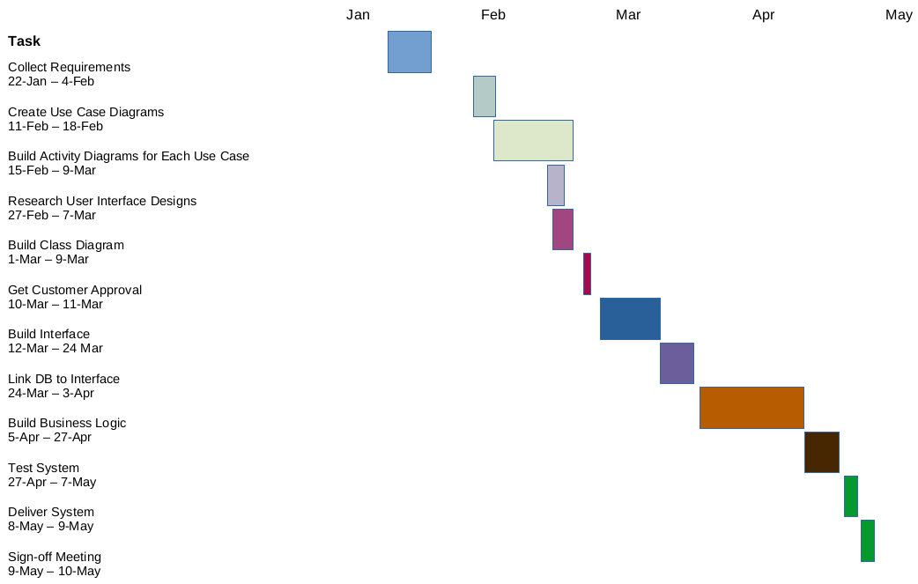

## References

Godskind, Ken. (2009, October 14). 5, 10, 15 seconds? How Long Will You Wait For a Web Page to Load? Smartberar.com

Retrieved from :

https://smartbear.com/blog/5-10-15-seconds-how-long-will-you-wait-for-a-web-p/